***DJ Simulator: Game Concept Overview***

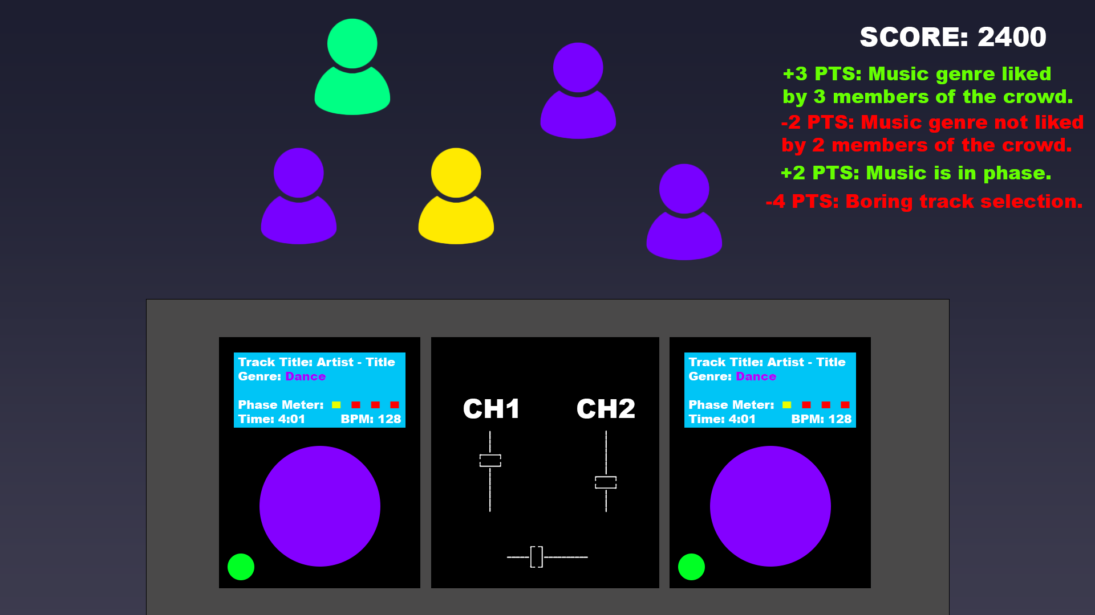

**Target Platform:** PC. PS5 support is being strongly considered, however, due to the depth and complexity of the gameplay controls, it may not be feasible to adapt a control scheme specifically for the DualSense.

**Game Engine:** Unity will be used due to its excellent multi-platform capabilities. Another reason that Unity is being used is due to the developer’s greater familiarity with the engine as opposed to Unreal. It has not yet been decided which exact version of Unity will be used, however it will most likely be an LTS branch due to greater stability. Furthermore, it is unlikely that the game will make use of the new features available in the latest Preview versions.

**Target Age:** PEGI 7 – no themes of violence, gore or foul language are expected to be present in the game. The reason for a rating of ages 7 or higher is due to the depiction of nightlife.

**Game Summary:** You are a DJ that needs to make it big in the nightlife scene. To succeed, you must perform excellent DJ sets that score plenty of points. In order to gain points, you must ensure you are picking the right tracks for the crowd and that you are mixing the tracks smoothly. Can you become the best ranked DJ and climb the points ladder?

**Game Outline:** Your view throughout the game will be of the DJ decks and of the crowd. The crowd will be colour coded based on the music that they like. The tracks that are being loaded onto the decks will also be colour coded based on their genre. The aim of the game is to score as many points as possible during a timed DJ set. There are multiple ways to gain (or lose) points.

 +  = 

Selecting tracks that appeal to the majority of the crowd will award points. As mentioned before, you must select genres of music that appeal to the crowd.

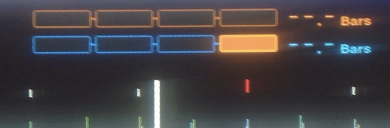

It is also important that the transitions between tracks are smooth and on beat. In the real world, Pioneer CDJ decks feature a phase meter, that shows the DJ if the two tracks currently playing are on beat or not. A similar system will be implemented into the game where the player can gain or lose points based on how on or off beat their tracks are.

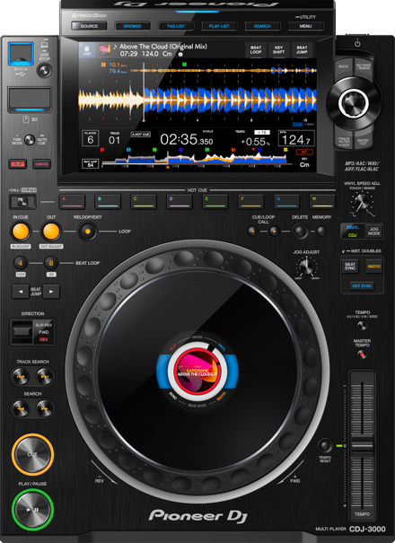 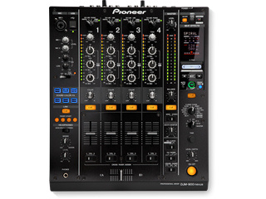

In order for the DJ to be able to beat match efficiently, some time and pitch algorithms from the industry-standard Pioneer CDJ-3000 decks and Pioneer DJM-900NXS mixer will be simulated. The features that will be available in-game will depend on how they will be able to be implemented within Unity.

**Unique Selling Points:** in-depth simulation of club standard DJ equipment, a unique points feedback system that vigorously analyses the player’s performance, effective crowd and beat matching game mechanics.

**Competitor Products:** DJ Simulator is a game within a niche that is very distant from those typically associated with gaming. Because of that, there are not many notable competitor products available.

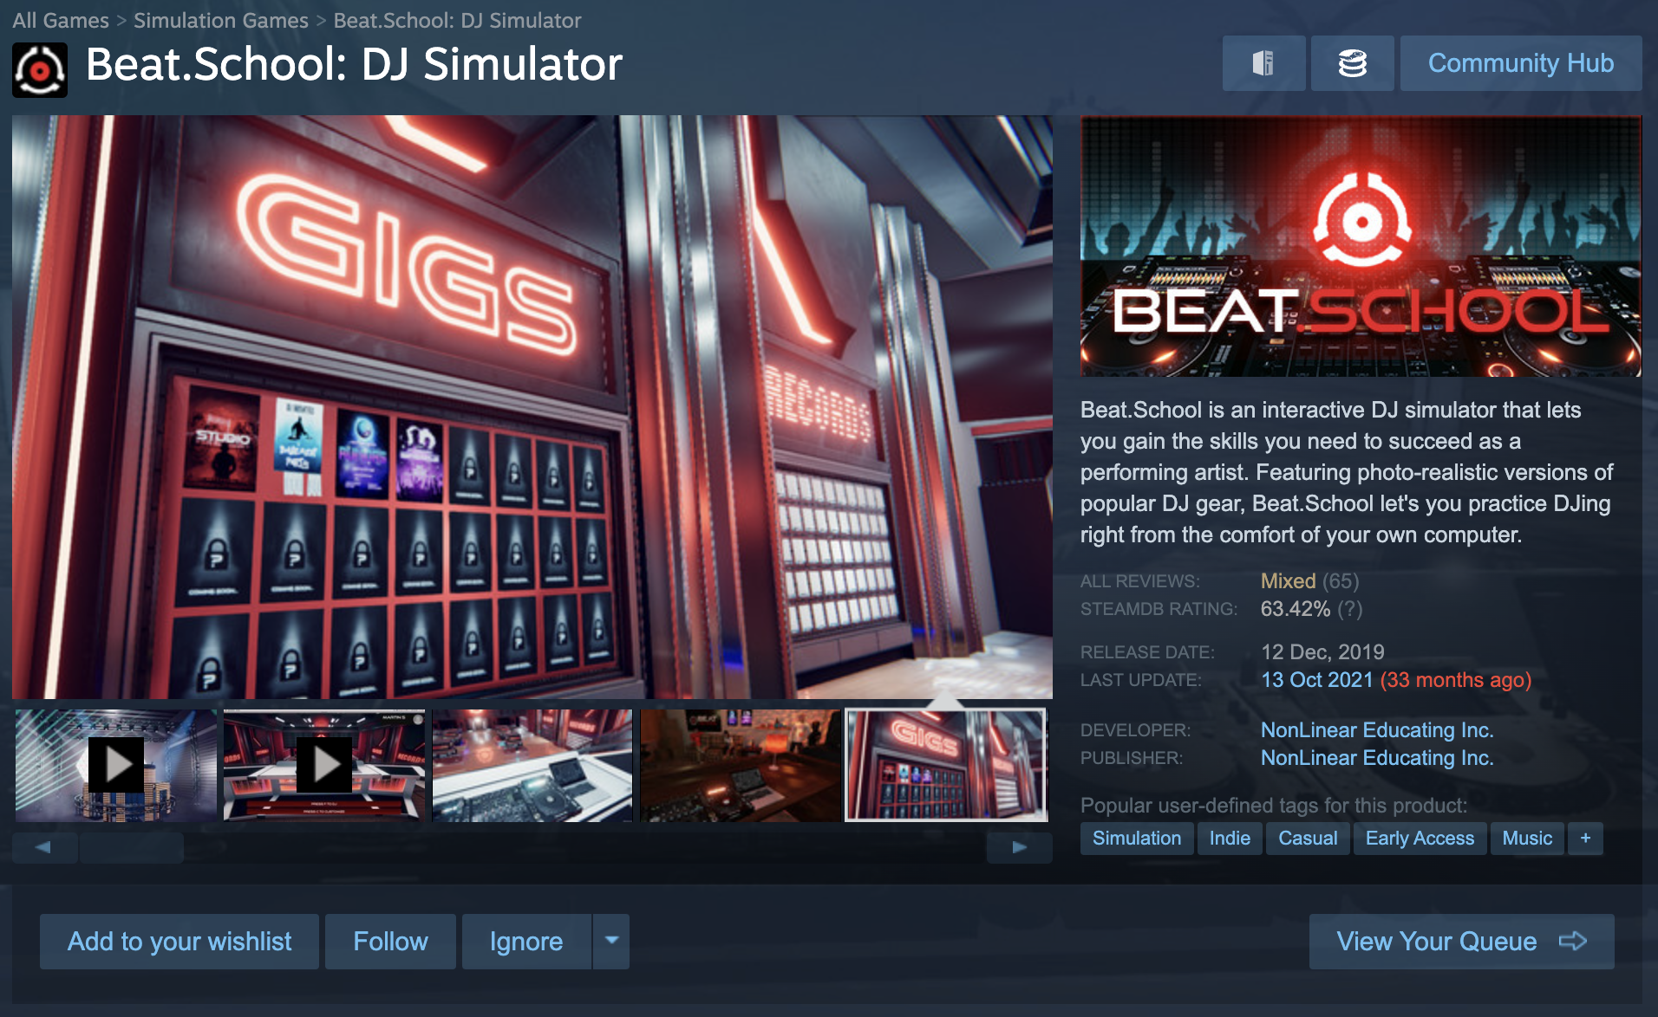

Beat.School is a product that seems to be comparable to DJ Simulator, however it lacks in-depth DJ features and systems.

**Resources:** music is a core component of this game, and due to copyright reasons, all music will need to be composed by the developer so that first-party ownership can be guaranteed. Due to many interactive elements, the DJ systems will be modelled by the developer too in order to allow animations and user interactivity to be fully functional. Assets such as the crowd and venues can be also made by the developer with the help of pre-fabs.